PSPJ- PROJECT
MODULE 6
TITLE ADAPTIVE QUIZ AND EXAM ENGINE
- ABSTRACT
The Adaptive Quiz & Exam Engine is a Java-based program that adjusts the difficulty of questions according to the student's answers. It uses Java Collections such as ArrayList, HashMap, HashSet, and TreeSet to store and manage quiz data. It also uses lambda expressions, functional interfaces, and Stream API to check answers, organise results, and generate performance reports. The program can save the results to a file and read them back. This project helps us understand how modern Java features can make a program more organised, useful, and easier to manage.
- ADVANTAGES

Adaptive learning: Adjusts question difficulty based on the student's answers.
Easy data management: Collections help store and organise questions and results.
Less repetitive code: Lambda expressions and streams simplify data processing.
Automatic scoring: Calculates correct and incorrect answers.
Better reports: Groups and sorts results for easy understanding.
File handling: Saves quiz results and reads them when needed.
Easy to expand: New questions and difficulty levels can be added.
Practical learning: Demonstrates important Java Collections and functional programming concepts.
- CODE
import java.util.*;
import java.util.function.*;
import java.util.stream.*;
import java.nio.file.*;
import java.io.IOException;

class QuizQuestion {
private String text;
private int answer;
private String difficulty;

public QuizQuestion(String text, int answer, String difficulty) {
this.text = text;
this.answer = answer;
this.difficulty = difficulty;
}

public String getText() {
return text;
}

public int getAnswer() {
return answer;
}

public String getDifficulty() {
return difficulty;
}
}

class QuizResult {
private String question;
private String difficulty;
private boolean correct;

public QuizResult(String question, String difficulty,
boolean correct) {
this.question = question;
this.difficulty = difficulty;
this.correct = correct;
}

public String getQuestion() {
return question;
}

public String getDifficulty() {
return difficulty;
}

public boolean isCorrect() {
return correct;
}
}

public class AdaptiveQuizModule6 {

public static void main(String[] args) throws IOException {

Scanner sc = new Scanner(System.in);

// 1. ArrayList: store quiz results
List<QuizResult> results = new ArrayList<>();

// 2. HashMap: store question banks by difficulty
Map<String, List<QuizQuestion>> questionBank =
new HashMap<>();

questionBank.put("Easy", new ArrayList<>(Arrays.asList(
new QuizQuestion("2 + 2 = ?", 4, "Easy"),
new QuizQuestion("5 - 3 = ?", 2, "Easy")
)));

questionBank.put("Medium", new ArrayList<>(Arrays.asList(
new QuizQuestion("6 x 7 = ?", 42, "Medium"),
new QuizQuestion("9 + 8 = ?", 17, "Medium")
)));

questionBank.put("Hard", new ArrayList<>(Arrays.asList(
new QuizQuestion("12 x 12 = ?", 144, "Hard"),
new QuizQuestion("144 / 12 = ?", 12, "Hard")
)));

// 3. HashSet: store unique questions
Set<String> uniqueQuestions = new HashSet<>();

for (List<QuizQuestion> list : questionBank.values()) {
for (QuizQuestion q : list) {
uniqueQuestions.add(q.getText());
}
}

// 4. TreeSet: keep difficulty names in sorted order
Set<String> orderedDifficulties = new TreeSet<>(
questionBank.keySet()
);

System.out.println("=== ADAPTIVE QUIZ ENGINE ===");
System.out.println("Available levels: " + orderedDifficulties);

System.out.print("Enter your name: ");
String name = sc.nextLine();

// Supplier: provides a message when requested
Supplier<String> welcome =
() -> "Welcome, " + name + "!";

System.out.println(welcome.get());

String difficulty = "Medium";
int totalQuestions = 5;

// 5. Quiz loop
for (int i = 0; i < totalQuestions; i++) {

List<QuizQuestion> currentList =
questionBank.get(difficulty);

QuizQuestion q = currentList.get(
i % currentList.size()
);

System.out.println("\nQuestion " + (i + 1));
System.out.println("Difficulty: " + difficulty);
System.out.println(q.getText());
System.out.print("Your answer: ");

int userAnswer;

try {
userAnswer = sc.nextInt();
} catch (InputMismatchException e) {
System.out.println("Please enter a whole number.");
sc.nextLine();
userAnswer = Integer.MIN_VALUE;
}

boolean correct = userAnswer == q.getAnswer();

// Add result to the ArrayList
results.add(new QuizResult(
q.getText(), difficulty, correct
));

if (correct) {
System.out.println("Correct!");

if (difficulty.equals("Easy")) {
difficulty = "Medium";
} else if (difficulty.equals("Medium")) {
difficulty = "Hard";
}
} else {
System.out.println(
"Wrong! Correct answer: " + q.getAnswer()
);

if (difficulty.equals("Hard")) {
difficulty = "Medium";
} else if (difficulty.equals("Medium")) {
difficulty = "Easy";
}
}
}

// 6. Predicate: select correct answers
Predicate<QuizResult> isCorrect =
r -> r.isCorrect();

List<QuizResult> correctResults = results.stream()
.filter(isCorrect)
.collect(Collectors.toList());

// 7. Function: convert a result into report text
Function<QuizResult, String> formatResult =
r -> r.getDifficulty() + ": " + r.getQuestion()
+ " - " + (r.isCorrect()
? "Correct" : "Incorrect");

// 8. Consumer: display each result
Consumer<QuizResult> printResult =
r -> System.out.println(formatResult.apply(r));

System.out.println("\n=== ANSWER REPORT ===");

results.forEach(printResult);

// 9. Count correct answers
long correctCount = results.stream()
.filter(isCorrect)
.count();

// Autoboxing: int converted to Integer
Map<String, Integer> scoreMap = new HashMap<>();
scoreMap.put("Correct", (int) correctCount);
scoreMap.put("Incorrect",
results.size() - scoreMap.get("Correct"));

// 10. Reduce: calculate total correct answers
int totalCorrect = results.stream()
.map(r -> r.isCorrect() ? 1 : 0)
.reduce(0, Integer::sum);

// 11. Comparator and sorted()
Comparator<QuizResult> byQuestion =
Comparator.comparing(QuizResult::getQuestion);

List<QuizResult> sortedResults = results.stream()
.sorted(byQuestion)
.collect(Collectors.toList());

// 12. distinct(), limit() and method reference
System.out.println("\n=== SAMPLE UNIQUE QUESTIONS ===");

results.stream()
.map(QuizResult::getQuestion)
.distinct()
.limit(3)
.forEach(System.out::println);

// 13. groupingBy() and counting()
Map<String, Long> levelSummary = results.stream()
.collect(Collectors.groupingBy(
QuizResult::getDifficulty,
TreeMap::new,
Collectors.counting()
));

// 14. joining(): build a summary string
String questionSummary = results.stream()
.map(QuizResult::getQuestion)
.distinct()
.collect(Collectors.joining(", "));

System.out.println("\n=== FINAL SUMMARY ===");
System.out.println("Student: " + name);
System.out.println("Score: " + totalCorrect
+ "/" + totalQuestions);
System.out.println("Correct: " + scoreMap.get("Correct"));
System.out.println("Incorrect: " + scoreMap.get("Incorrect"));
System.out.println("Correct answers counted: " + correctResults.size());
System.out.println("Questions by difficulty: " + levelSummary);
System.out.println("Questions attempted: " + questionSummary);

// Display sorted results
System.out.println("\n=== SORTED RESULTS ===");
sortedResults.forEach(printResult);

// 15. Write report to a file
List<String> report = new ArrayList<>();

report.add("Adaptive Quiz Report");
report.add("Student: " + name);
report.add("Score: " + totalCorrect + "/" + totalQuestions);
report.add("Difficulty summary: " + levelSummary);

results.stream()
.map(formatResult)
.forEach(report::add);

Path reportPath = Paths.get("quiz_report.txt");
Files.write(reportPath, report);

// 16. Read file lines as a stream
System.out.println("\n=== REPORT FROM FILE ===");

try (Stream<String> lines = Files.lines(reportPath)) {
lines.forEach(System.out::println);
}

System.out.println("\nReport saved to quiz_report.txt");

sc.close();
}
}

- OUTPUT
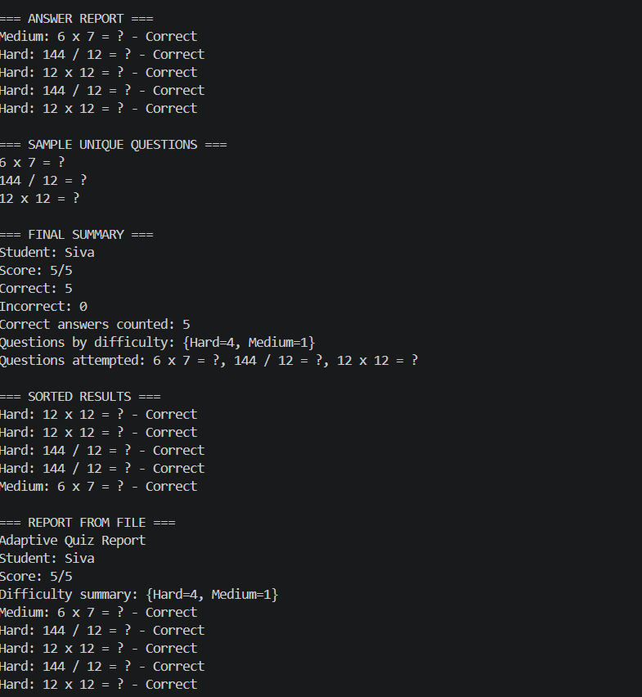
- CONCLUSION
The Adaptive Quiz & Exam Engine helped us understand how Java Collections, lambda expressions, and Stream API can be used in a real-world application. It makes the quiz interactive, manages results automatically, and generates a report. Through this project, we learned how to organise data, process information, and use modern Java features to build a useful and easy-to-manage program.

